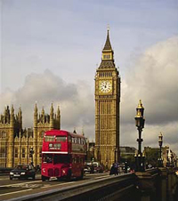
- Trafalgar Square is in London.
- Moscow is the capital of the UK.
- Moscow is different from London.
- You don't want to visit Great Britain.
- London is the biggest city of the UK.
- There are a lot of places to visit in London.
- London is one of the most interesting and famous cities in Europe.
- There are no Art galleries in the capital of the UK.
- London is not a beautiful city.
- There are a lot of Museums and Theatres in London.
- Big Ben is situated in the USA.
- The Queen in the head of Great Britain.

